Welcome to
Falls Church Consumer
Wellness Center!
6245 Leesburg Pike, (Route 7) Suite 420
Falls Church, VA 22044
703.531.4653

The Falls Church Wellness Center is located in the Fairfax County Building on Route 7 at Seven Corners.  (Center hours and information following photos.) | 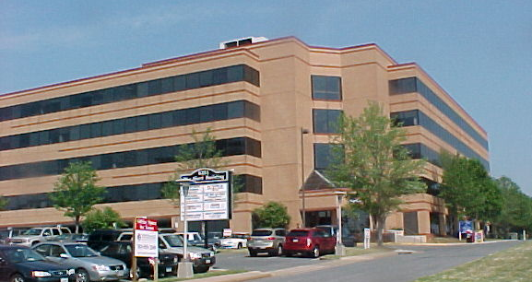
There is only one entrance into the building – to a small lobby. Take an elevator to the fourth floor and take the hallway to the right.  (Restrooms are located in this hallway by the water fountain.) | 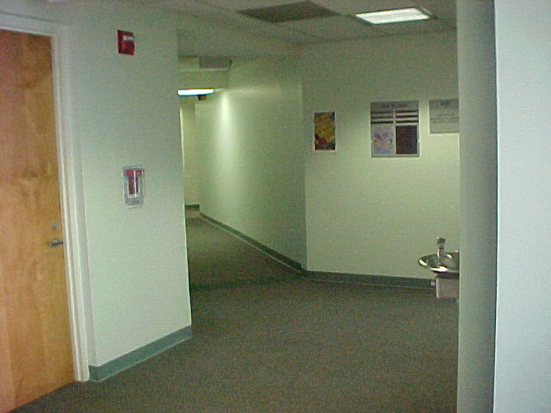
About 35 feet down the hallway to the right from the elevators, you will see two glass doors on the right.  This is the entry to the Wellness Center.  The small table inside the door has a sign-in sheet, and there is information, a calendar of events and other brochures and notices in this area of the center. | 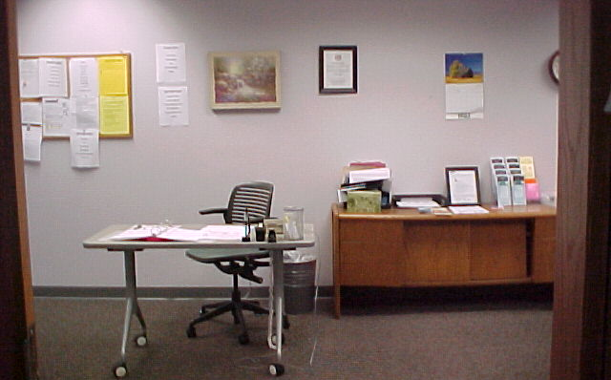
To the left of the sign-in table there is a conversation area, books and games, and the kitchen.  Snacks are available – at little cost.  Free lunch is served daily.  Peer-created artwork is mounted throughout the center. | 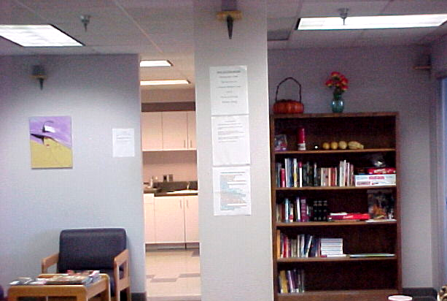
To the right of the sign-in area is a game table, and the computer room. | 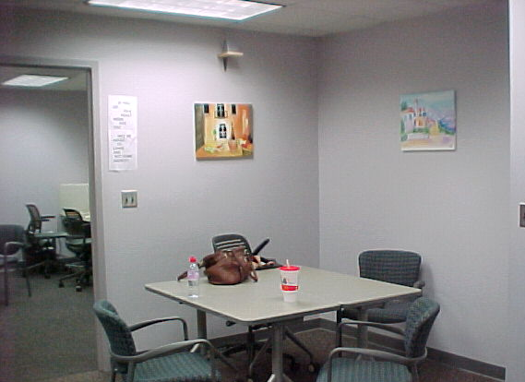
The computer room is a busy area, and printers are available. | 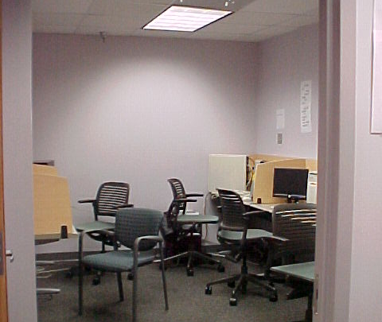
To the far right of the sign-in area are offices and the clothing closet. | 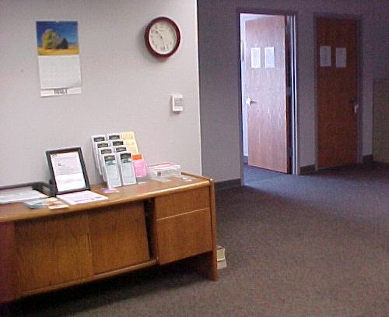
Behind the sign-in area is the board room. Groups meet, and people have lunch here.  Coffee and soft drinks are available; snacks are available for a minimal charge. | 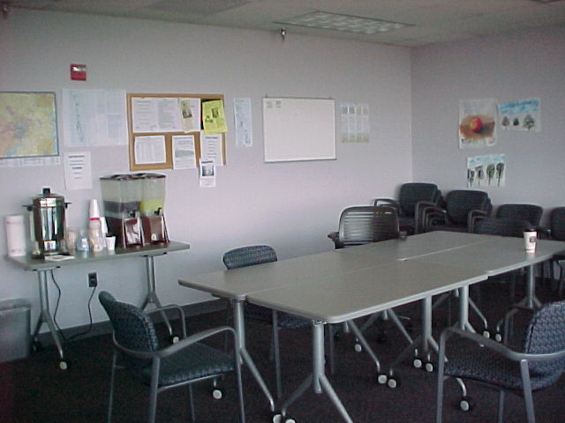
To the right of the board room area is the TV room. | 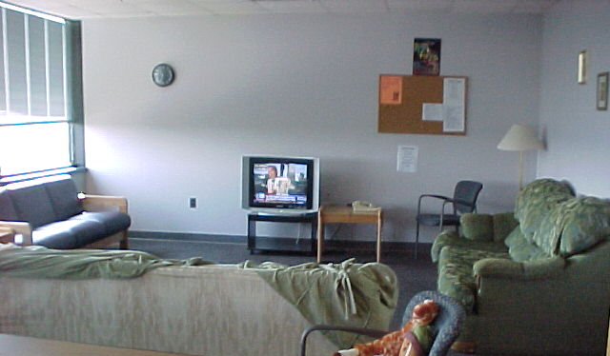
There is a great view of the Arlington area from their board room/lunch area. | 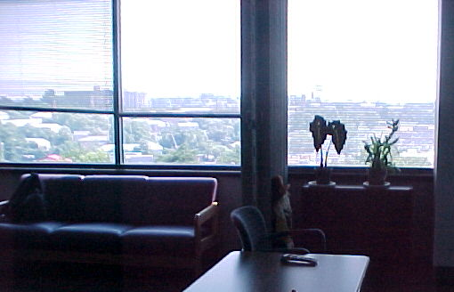
Falls Church Consumer
Wellness Center Information

- Mission: The Mission of the FCCWC is to provide a safe, stigma-free, low-stress independent place for mental health consumers run by mental health consumers.
- How it works: The drop-in center members and leadership share individual and collective ideas about the daily operations. Drop-in Center members are encouraged to participate at a level at which they feel comfortable. They may choose to relax in a supportive environment and/or assume and active role in activities and events.
- Why it works: Individuals who experience similar life challenges often have the ability to assist and respond to the needs of others in an empathetic and compassionate manner. This unique type of assistance and caring provides a special, valuable source of support to help make people feel accepted and to reach new wellness potentials.
- Drop-In Center Principles:
- The drop-in center provides a safe, welcoming environment that encourages a sense of belonging and promotes wellness.
- Self-help, (mutual aid,) is at the core of all center activities and interactions demonstrated by acceptance and mutual respect.
- Self-help and peer support provide a great resource that promotes wellness, recover and hope.
- Consumers are empowered to assume leadership roles in managing center operations and goals.
- The collaborative partnership between center members and sponsoring agency enhances and encourages decision-making in center operations.
- Diversity and inclusiveness are recognized as key components of the center reflecting the importance of persona life experience, preferences and cultural traditions in personal recovery.
- The center environment, groups and resources are designed to identify and satisfy needs and goals, promote self-esteem and enrich the lives of members.
Note: The Falls Church Consumer Wellness Center was the second consumer-founded and consumer-operated drop-in center in northern Virginia! (Opened in October 2006 and has is continually expanding services since that time.)

Contact Information |  Website: www.novapeers.pbwiki.com/CWC   Email: consumerwellnesscenter@yahoo.com   Phone: 703.531.4650
Location  How to get there | 6245 Leesburg Pike, Suite 420 Falls Church, VA 22044  Falls Church Consumer Wellness Center is located in the Fairfax County Government building on Leesburg Pike at Seven Corners. They are on the fourth floor, in the suite directly across the hall from the Fairfax County Drug and Alcohol Services office.  - Local Landmarks: The Seven Corners Shopping Center, (Shoppers Food Warehouse, Michaels, Home Depot and Chipotle are across the street. There is a bus stop on the lower level of the shopping center. (Note: If you have mobility problems, use a Leesburg Pike bus stop, as the walk up the hill can be difficult, especially during bad weather, even on the stairs.) Sears, (the old Lord and Taylor store,) is one building to the east of the Fairfax County Building.) Metro busses and Fairfax busses are available: www.wmata.com/ and  http://www.fairfaxcounty.gov/connector/south.htm  - Van transport daily from to and from Bailey’s Crossroads Shelter. Call for more information: 703.531.4650.  - There is ample parking including handicapped spaces available. Parking lot, entry, and entire building is accessible by persons with mobility and other impairments.  - There are bike racks for locking up your bike.
When We’re open | Monday – Friday 10:00AM – 4:30PM  ➢Inclement Weather Policy: Please call ahead, and since Falls Church Wellness Center is located in a county government building, we follow the Fairfax County government closing policies.  Please call 703.531.4650 if conditions are extreme.
What you need to do: | Please sign in when you arrive. (Consumers from Arlington and Alexandria areas are very welcome!)
Activities | ☺ Daily, no-cost lunch, computers/internet access, board games, TV room, movies, snacks (small charge,) clothing closet, Thanksgiving dinner, holiday open house, volunteer opportunities, and this center carries a lot information about the consumer activities in northern Virginia and how to access conferences, trainings and other community events. Microwave available for heating your own lunch/snacks.  Phone available; please limit calls to 15 minutes.
Special Events |  Thanksgiving dinner and Holiday Open House in December. Call Consider attending board meetings to contribute your ideas and volunteer to help. (The Holiday Open House in December is one if the best in the area!)
Center Rules | - Respect others at all times  - No fighting or horseplay  - No sleeping in the center  - No smoking in the building (Go to lobby, and to the back of the building for smokers’ area.)  - No illegal drugs, alcohol, or weapons, (or pocket knives)  - No food or drink near or in the computer room  - No panhandling  - No name calling  - No swearing, or “vulgarity” of any kind  - Everyone must wear shoes and shirts at all times.  - Everyone must clean up after themselves  - Eating only allowed in dining area.  - You must be 18 years or older to use the center.
Peer Comments on Falls Church Consumer Wellness Center

Peer Comment #1 | “I come here every day. I’ve met some good people here.”
Peer Comment #2 | “Sometimes I meet my girlfriends here, and we go across the street to the shopping center to window shop.”
Peer Comment #3 | “I’m glad I have a place to go – the shelter tells us we have to leave during the day. Before I knew about this place, I would just walk the streets. I got hot, and I was hungry. Now I come here. When I get some housing, I’m coming back because it’s comfortable and relaxed here.”
Peer Comment #4 | “The staff here is great – we have a good time. I’ve got someone to talk to, and things to do now. Before, I stayed home all day, all week – it was so boring. Now, I have friends and I look forward to coming here.”
Want List | - Books, magazines, art and craft supplies.  - Good, clean and usable clothing (appropriate for the season).  - Toner cartridges for fax and printers. (Toner for printers and fax are very much needed, please call for the specifics on the brands needed: 703.531.4653.)  - We also need paper towels, napkins, disposable bowls, plates and flatware, trash can liners and snacks like top-ramen noodle soups, cup ‘o soups, candy bars, chips, sugar-free lemonade and drink mixes, coffee, (drip grind,) and soda pop. Microwaveable foods like popcorn, hot pockets, and Easy Mac. are always needed. Please call ahead if you are bringing items needing refrigeration or frozen foods.  - Lunch foods: Canned ravioli, or spaghetti, lunch meats, bread, crackers and cookies, mayonaisse, mustard, catsup, ramen noodle soups, canned soups, beef hotdogs and pickle relish. Please call ahead if you are bringing items needing refrigeration or frozen foods.  - Food and help with preparation for Holiday open house and Thanksgiving dinner is very much needed and people to help set-up and clean up.  - Mental health consumers with special talents and skills to lead groups, and assist with activities.  - Crafts and arts supplies and board or card games are needed, as well as volunteers to lead arts and crafts groups.  - Small, self-defrosting chest-style deep freezer for food storage.  - Financial contributions are always welcomed! (Falls Church Wellness Center is a registered 501(c)(3) organization; all contributions are tax-deductible.)
Board Members | Please call for more information about board meetings: 703.531.4650
Smile Project says: | Please call, request a tour! This was our second drop-in center in northern Virginia and we’re so proud of this center! Peer-leadership continues to expand services and meet needs of consumers. Peers come from all over the northern Virginia area to visit. Mental health facilities and group homes bring peers to visit. This is a very comfortable center, and very busy!  Staff is very welcoming and helpful. We enjoyed meeting them and working alongside them.  With patience and persistence, this center created a way to be available to peers from a local shelter – as the shelter requires people to leave during the day. Falls Church CWC picks-up and drops-off at the shelter daily during the week. What a great service! Shelter life can be really tough, and it’s a lot easier with a safe place to be during the day. We’re hoping that they will extend hours and maybe even open on the weekend.  Their lunches are good. I enjoyed eating with other peers, and this center rates high on casual comfort and high energy! (Currently they are serving 20-50 people per day.)  FCCWC staff is trained on CPR, first aide, use of defibrillator, and crisis intervention.  The Smile Project is expresses our thanks to the staff of FCCWC for continuing to find ways to offer support and opportunities to peers in our community.
→ Mental Health Recovery is Possible!
The Smile Project is a peer-innovated and peer-accomplished project funded through a grant awarded from the Northern Virginia Regional Recovery Work Group, (RRWG,) May 2008 and through the assistance of the dedicated leadership of our local drop-in centers.
- The Smile Project was designed specifically to inform our community about drop-in centers and promote their use. Recovery doesn’t happen in a vacuum; understanding and support are essential. Drop-in centers provide safe, stigma-free places to find friends and opportunities for personal growth as well as enjoy ourselves and others.
- Our thanks to the Laurie Mitchell Employment Center, a consumer-founded and consumer-operated computer training and employment center, for hosting this information, as well as encouraging and supporting the Smile Project during the entire process of creating this information.
- Thanks for R., S., and the Executive Committee at the northern Virginia RRWG for their patience and support in making this project available to peers and others in our area, and around the world.
- Our special thanks to all of our peers and other consumers and people who’ve supported us and helped us with so many big and little things to get this information on-line. We couldn’t have done this so smoothly without your help!
- We offer our peer leaders who have founded and are operating these centers our respect and many thanks from our community, and those yet to come.

KS and VT –
Smile Project July 2008

