Welcome to
Reston Drop-In Center
1820 Michael Faraday Dr. Reston, VA 20190
703.437.5105

This is the building as you would see it from the street. | 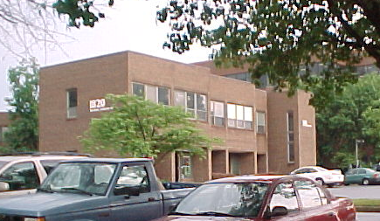
 | 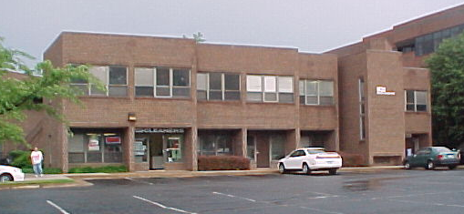
At the PRS entrance on the ground level. | 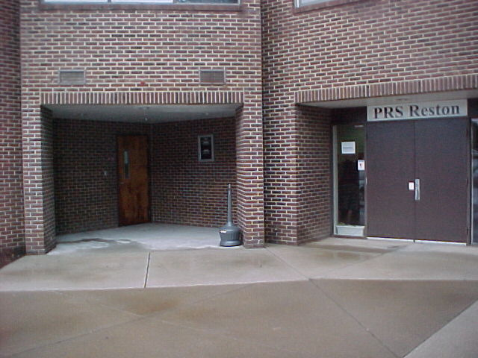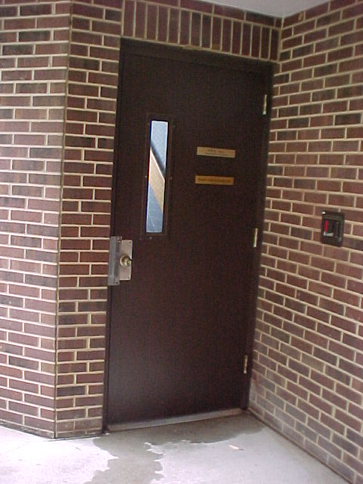
 | 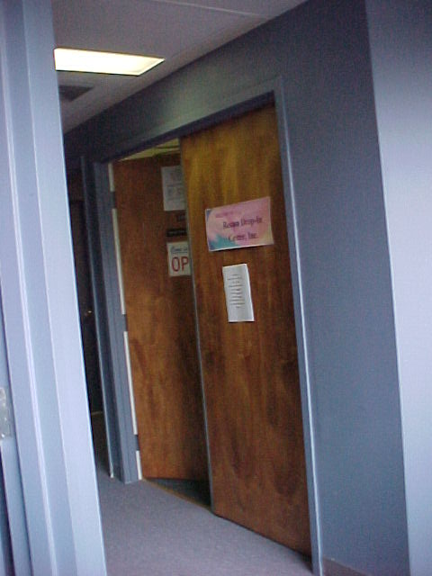
 | 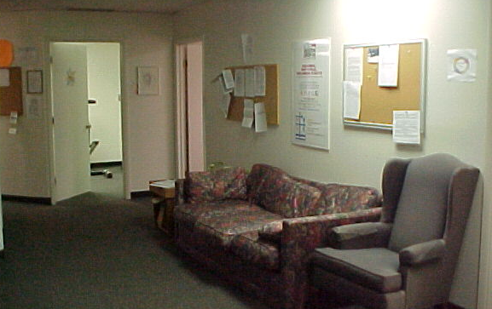
 | 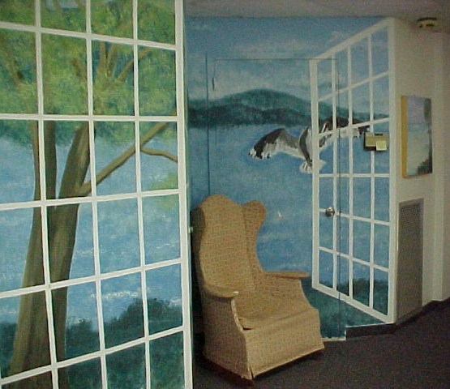
 | 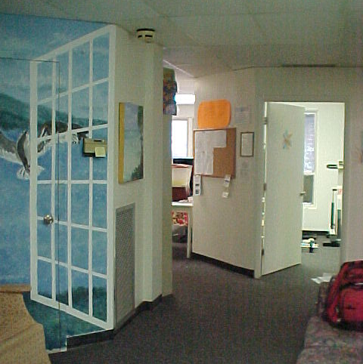
The TV/Movie room is to the right of the conversation area. Cable, VCR, DVD available. There are a lot of movies, or bring your own. | 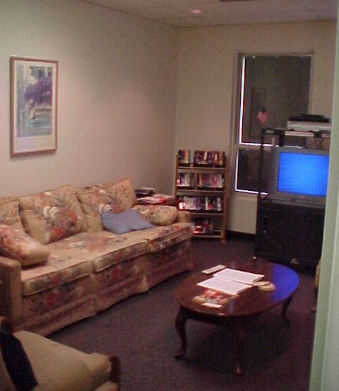
As you enter the general activities area, the kitchen is to the left.  Free lunch is served daily, and snacks can be purchased for minimal charge. There is a microwave you can use to heat your own lunch/snacks. | 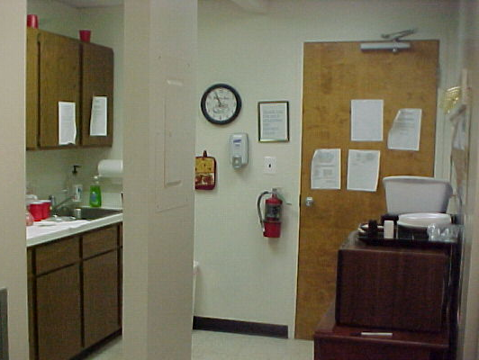
Three computers and a printer are available in the general activities area.  People gather in this area for conversation and to share news. | 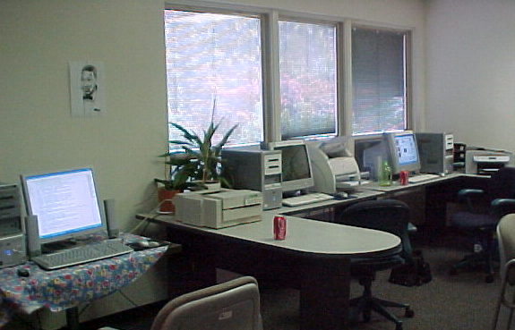
The Fresh Fruit Bar is next to the coffee pot and soft-drinks in the general activity area.  (Your first cup of coffee is free; the next ones are 25 cents each. Sodas are fifty cents. | 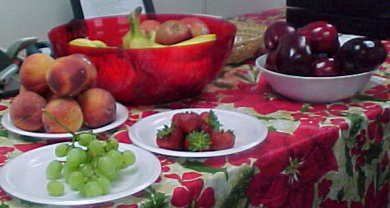
The arts and crafts room is next to the kitchen, off the general activities area. | 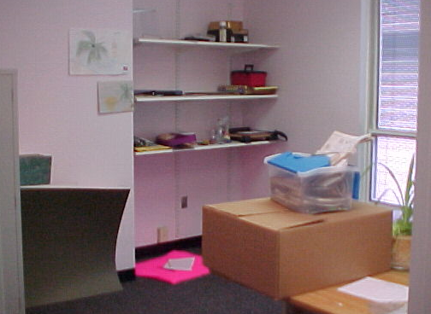
The board room is used for private conversations, groups, meetings, and has a treadmill and other exercise equipment. | 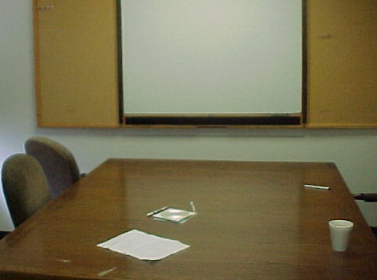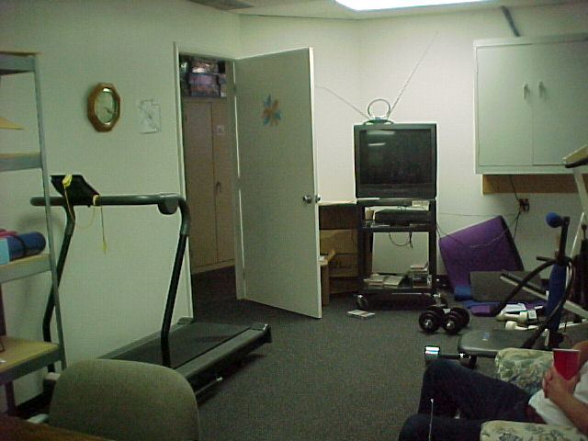
Welcome to
Reston Drop-In Center
1820 Michael Faraday Dr. Upstaris
Reston, VA 20190
703.437.5105

Mission: The Mission of the Reston Drop-In Center is to provide a safe, stigma-free, low-stress independent place for mental health consumers run by mental health consumers.

How it works: The drop-in center members and leadership share individual and collective ideas about the daily operations. Drop-in Center members are encouraged to participate at a level at which they feel comfortable. They may choose to relax in a supportive environment and/or assume and active role in activities and events.

Why it works: Individuals who experience similar life challenges often have the ability to assist and respond to the needs of others in an empathetic and compassionate manner. This unique type of assistance and caring provides a special, valuable source of support to help make people feel accepted and to reach new wellness potentials.

Drop-In Center Principles:
- The drop-in center provides a safe, welcoming environment that encourages a sense of belonging and promotes wellness.
- Self-help, (mutual aid,) is at the core of all center activities and interactions demonstrated by acceptance and mutual respect.
- Self-help and peer support provide a great resource that promotes wellness, recover and hope.
- Consumers are empowered to assume leadership roles in managing center operations and goals.
- The collaborative partnership between center members and sponsoring agency enhances and encourages decision-making in center operations.
- Diversity and inclusiveness are recognized as key components of the center reflecting the importance of persona life experience, preferences and cultural traditions in personal recovery.
- The center environment, groups and resources are designed to identify and satisfy needs and goals, promote self-esteem and enrich the lives of members.
Note: The Reston Drop-In Center was the second consumer-founded and operated drop-in center in northern Virginia! (Opened January 2007, and is the only drop-in center to offer a Warm Line service.)

Contact Information |  Email: restondropincenter@yahoo.com   Phone: 703.437.5105   Fax: 703.481.9710
Location  How to get there | 1820 Michael Faraday Drive, Second Floor, Reston, VA 20190  The Reston Drop-in Center is located in an office park, above a dry-cleaner, and PRS. (Please see pictures below.) Note: There is no elevator in this building; restroom is not accessible. Reston Drop-In Center is aware of the hardship this causes, and would very much like to move into an accessible building where rent would be affordable.  - Local Landmarks: The PRS day program is on ground-level and to the right of the stairwell to the third floor where Reston Drop-in Center is located. You will see a dry cleaning business and other small businesses on the ground floor. Metro busses and Fairfax busses are available.  - Reston Drop-in Center has a new van, and are looking for a driver. (No CDL required.)  - There is ample parking including handicapped spaces available.  - There is no elevator, and the restroom is not accessible. There are parking spaces for people with disabilities close to the building.
When We’re open | Monday – Friday 10:00 – 4.30PM, Saturday 12 – 5PM.  ➢Inclement Weather Policy: Please call ahead, and generally we follow Fairfax County closings.   Please call 703.437.5105 if conditions are extreme.
What you need to do: | Please sign in when you arrive.
Activities | ☺ Daily free lunch, computers/internet access, board games, TV room, movies, snacks, Thanksgiving dinner, holiday open house, volunteer opportunities, and this center carries a lot information about the consumer activities in northern Virginia.  Microwave available for heating your own lunch/snacks, and phone available; please limit calls to 10 minutes.  WARM LINE: Peer counseling available during center’s open hours by phone, (703.437.5105). A warm line is a phone number to call if you are feeling unwell and need an understanding and supportive person to speak with. All peers/consumers are encouraged to use this line to get through those “difficult moments.” Peer counseling is a way peers work together to help each other get well and stay well. All calls are confidential.
Special Events | Thanksgiving dinner available and Holiday Open House in December. (Planned activity: Northern Virginia area-wide consumer picnic at a local park.) Call for more information about events. 703.437.5105
Center Rules | - Respect others at all times  - No fighting or horseplay  - No sleeping in the center  - No smoking in the building (Go to lobby, and to the back of the building for smokers’ area.)  - No illegal drugs, alcohol, or weapons, (or pocket knives)  - No food or drink near or in the computer room  - No panhandling  - No name calling  - No swearing, or “vulgarity” of any kind  - Everyone must wear shoes and shirts at all times.  - Everyone must clean up after themselves  - Eating only allowed in dining area.
Peer Comments on Falls Church Consumer Wellness Center

Comment #1 | “I really enjoy coming here. We have some good people here, and it’s very comfortable.”
Comment #2 | “I like it here. Before I never ate lunch.”
Comment #3 | “We like our coziness.”
Comment #4 | “I like the artwork all over the place.”
Want List | Books, magazines, art and craft supplies, good, clean and usable clothing (appropriate for the season,) and toner cartridges. (Toner for printers and fax are very much needed, please call for the specifics on the brands needed: 703.531.4653.) We also need paper towels, napkins, disposable bowls, plates and flatware, trash can liners and canned soups/spaghetti/ravioli, snacks like top-ramen noodle soups, candy bars, chips and soda pop. Microwaveable foods like popcorn, hot pockets, etc. are always needed. Please call ahead if you are bringing items needing refrigeration or frozen foods.  Financial contributions are welcomed! (Falls Church Wellness Center is a registered 501(c)(3) organization; all contributions are tax-deductible.)  Food and help with preparation for Holiday open house and Thanksgiving dinner is very much needed and people to help set-up and clean up.  Mental health consumers with special talents and skills to lead groups and assist with activities.  Volunteer van drivers needed: must be able to pass a background check, and have a clean driving record. No commercial drivers’ license needed.
Board Members | There are many consumers on the board. Please call for more information about board meetings: 703.437.5105
Smile Project says: | Cozy – this place really has a feeling of comfort! Stop by and enjoy lunch! This center is beautifully decorated with murals and art that were done by consumers. This drop-in center also has a fresh fruit bar! Though smaller than other centers, is has to be one of the most comfortable. There are large windows throughout the center, making it bright and cheerful. Most people are in the one, large general activity area talking and working on computers and enjoying themselves. They have some great exercise equipment in the board room, and a spacious arts and crafts area.  The hospitality is warm and very inviting here!  Staff here has CPR, crisis intervention and first aide training, and are very responsive to consumer needs in the community. If you’re thinking about working with a board, this might be a good choice. They were our first drop-in center in northern Virginia, and they’ve got a beautiful center to show for all the work they have put into it!
→ Mental Health Recovery is Possible!
The Smile Project is a peer-innovated and peer-accomplished project funded through a grant awarded from the Northern Virginia Regional Recovery Work Group, (RRWG,) May 2008 and through the assistance of the dedicated leadership of our local drop-in centers.
- The Smile Project was designed specifically to inform our community about drop-in centers and promote their use. Healing toward recovery doesn’t happen in a vacuum; understanding and support are essential. Drop-in centers provide safe, stigma-free places to find friends and opportunities for personal growth as well as enjoy ourselves and others.
- Our thanks to the Laurie Mitchell Employment Center, a consumer-founded and consumer-operated computer training and employment center, for hosting this information, as well as encouraging and supporting the Smile Project during the entire process of creating this information.
- Thanks for R., S., and the Executive Committee of the northern Virginia RRWG for their patience and support in making this project happen.
- Our special thanks to all of our peers and other consumers and people who’ve supported us and helped us with so many big and little things to get this information on-line. We couldn’t have done this so smoothly without your help!
- We offer our peer leaders who have founded and are operating these centers our respect and many thanks from our community, and those yet to come.

KS and VT –
Smile Project July 2008

